**Course 2 Task 2 Lessons Learned Report**

* Did you learn anything of potential business value from this analysis?

The most defaults happen to people with the lowest limit balances.

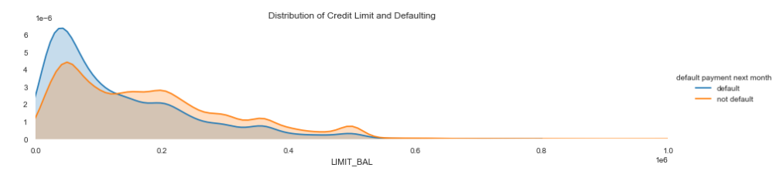

Age seems to follow a similar distribution.

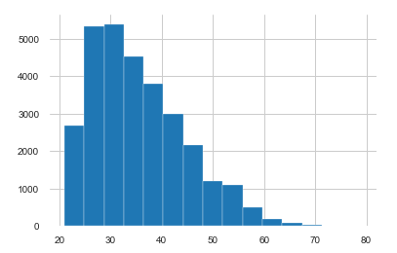

Counts by age(x-axis).

* What are the main lessons you've learned from this experience?

I might have to discretize some numerical columns in the next step to find some clearer relationships.

I ran two separate reports to see the impact of breaking the data differently.

I had to do a lot of internet searches to get commands to work.

* What recommendations would you give to the Data Science team regarding your findings?

We need to find what variables really impact the default rate to create a model as a next step.

There is an increasing relationship with the zeros decreasing on the Pay and Bill_Amt columns, but I am not sure if this variable will help or not yet.

Other observations:

